Greetings from the past!
Hello future painless prep capstone students! My name is Josef Stanek, I was one of the main code architects of group 4, Pane Perfect during the spring semester of 2026.

Understanding a past groups code can be difficult, especially when it's for a large and daunting project like a capstone, so I am writing this document as a way to help try to make that process easier and smoother for those using our groups code as a starting point!

This document will be split into a few sections listed below, feel free to skip around using the navigation bar, but I recommend following it as I’ve set it up as I’ve tried to write this in a way that you can follow along and by the end understand as much of this project as you can!
Sections:
- Initial Setup
  - Android Studio
  - Using your Android device to run the program
  - Using the application
- Code Overview
  - Classes
  - Functions
  - Test cases & Auto Documentation
- Final Notes
  - Mistakes we made
  - Ideas to iterate on
  - Final remarks

Initial Setup

Android Studio
Our project was built and developed within the application “Android Studio”, an IDE with the specific goal of making developing Android applications simpler, and more intuitive.

Setting up Android Studio is very simple and only requires you to head to their dedicated site to download the installer!

At the time of writing this, the Android Studio download site looks like this:
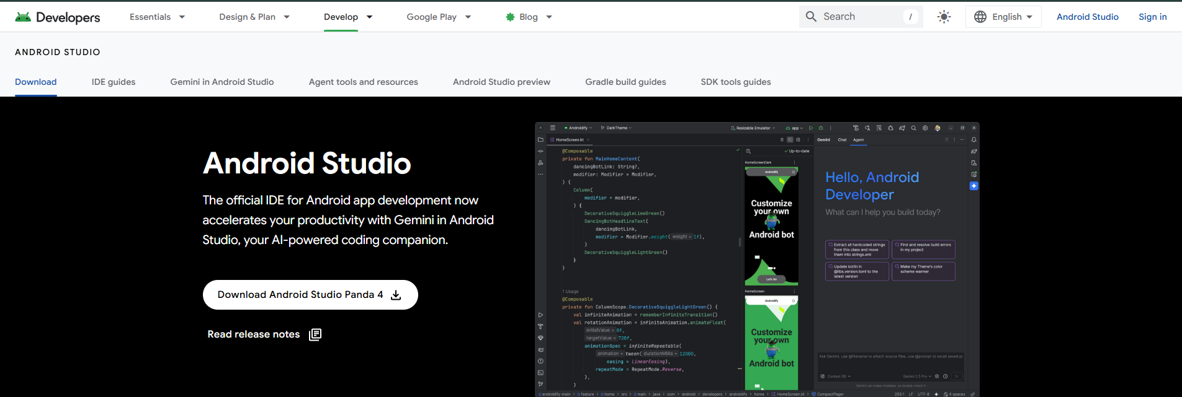
All it takes is a click on the large download button, and then running the installer once its downloaded.
The image above is my installer that I obtained from the website back when we first started using Android Studio in march!

Once launched, Android studio will open up and allow you to select a project to open, or create a new project. To run our project, I recommend creating a local copy of the repository provided to you, and selecting the “open” button on the Android Studio project selection screen. From there path to the local repository, and select it as your project to open!
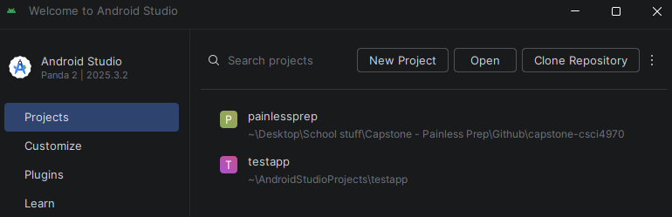
- On a more in-depth note, our project is built upon the “Empty Views Activity” within the new project screen. All this means is that our project is built upon an older standard of Android project. We utilize .xml files to help us design our applications UI, while more modern projects utilize Jetpack Compose to do the design right within the apps .kt file! That may be something worth noting as you expand upon our ideas.
From here you can open the project, and we can dive into running the application on your Android Devices!
Another quick note is that Android Studio is a bit more in-depth than other IDE’s, utilizing Gradle to help build and make our projects work. Before going much further, its important to note that sometimes there will be issues with Gradle when first importing a project. The project hierarchy should look something like this once everything is settled:
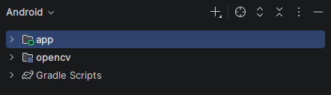
If not try following some of the steps below!
- Wait for a minute or two, Gradle needs some time to build the project together, which will then switch to this proper hierarchy.
- Check that the dropdown of the hierarchy states “Android” and not one of the other options.
- Check that you have a folder set for Gradle to download itself to.
  - It should alert you in the bottom right if this is the issue! I solved it for myself by just creating a separate folder outside of my groups repository folder for Gradle to utilize!

Using Your Android Device to Run the Program
At this point, you should be able to view the code under, and all Gradle scripts that come with the project within the hierarchy. Now we will move onto actually running the program and making sure you understand the process of changing code, and running it properly!

FOR NON-ANDROID USERS - Theres one very important thing to note here:
- ANDROID STUDIO CREATES ANDROID APPLICATIONS
That means, if you’re utilizing an IOS device, you would need to make the code cross-platform to run it. There is a way around this though! Android studio provides a built in Android Device Emulator, that should be selected as your mode of running by default! (You can check by looking at top of your android studio window, as underlined in red below!
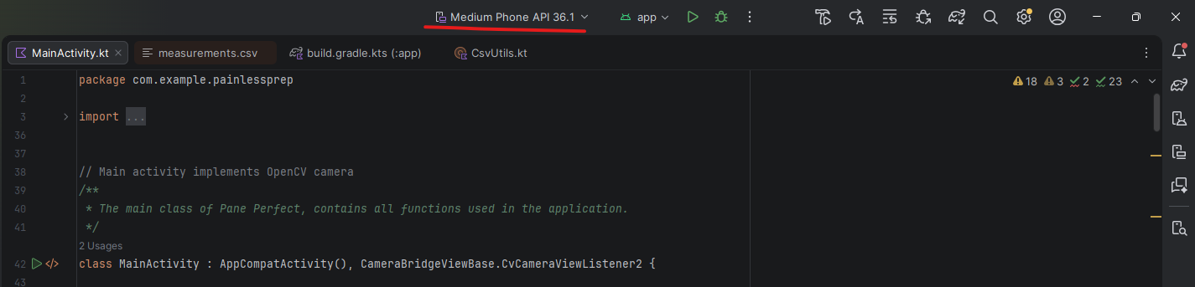
If you did not install this during the installation process, you may need to search online to find the proper way to install it! However, this emulated device does not allow the program to properly access a camera, and therefore the project can not be properly run without a physical android device, so therefore it is highly recommended for any code developers to have physical android phones for this project.

If you are a student who has an Android device, the process is a bit more complicated but worthwhile!

To allow android studio to install this application, you must enable “Developer Options” within your mobile device, which essentially labels you as a developer, and lets you access a bunch of very useful features for android development!

To enable developer options, enter your devices settings app, then move to the “About phone” section. Within here, you must tap multiple times on the “Build number” label, you will know its working as you tap and a notification pops up warning you that “in x amount of taps you will be a developer”. Keep tapping until you are alerted that you are now a developer, close and kill the settings process, and re-open settings to now move to the “systems” section. At the bottom of systems there should now be an advanced section containing “Developer Options”. Entering here you are subject to a large and vast amount of options, we are focused on three.
- Turn on the “Use Developer Options” toggle
- Scroll down under debugging to find and enable “USB Debugging”
- Scroll down under debugging and enable “Wireless Debugging”
Once done, you are now able to actually debug and test apps on your physical device! Both USB and wireless essentially do the same thing, just have different connection medias.
- USB requires you to plug your device into your laptop, desktop, or whatever you have your project on
- Wireless requires you to pair the device via a QR code within android studio
  - To do so, first click on the wireless debugging option in your devices settings, then in android studio click the dropdown next to the android emulator and click “pair devices using Wi-Fi” then you can choose to either scan a qr code or input a specific code, whichever you choose you then must click the same in your android device, and follow the instructions to connect!

Once connected, you should see the running device change
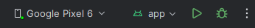
- This green dot means that it is a physical device!
From here, you can simply click the green triangle “run” button, and the Gradel daemon should begin building a proper build, before installing the app on your device to run!
- Quick tip! You can check how the build is doing by clicking on the hammer icon that appears in the bottom left corner of Android Studio after running the app, this can be helpful in diagnosing bugs, errors, and more!
- 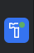

Using the application
Now we can move onto using the application. For this you will need two external things
- An OpenCV chessboard
- OpenCV AruCo markers
I created a convenient sheet that you can utilize by printing out at a campus printer, your chessboard square size should print to around .022mm, and the aruco markers should print to around 2 inches. Please ask Dr. Siy or the Painless Prep sponsors for the aruco related sheets to obtain them!

Lets begin,
On startup the app will likely prompt you stating that there is an android app compatibility issue. This is expected, our theory is that currently there isn't a public build of OpenCV android built for this specific compatibility. Note that by the time you are reading and starting this project this might be fixed! You can test by downloading your own build of opencv android from their releases page, and importing it manually following the library importing guide that can be found online for android studio.
If you're prompted with this, just click ok and move forwards, it should next ask you for permission to use the camera, grant it access, there is a chance the app will crash here due to not having permission for the camera, yet needing it to display the screen. Just restart the app and you should be fine.
From here click the information button in the top left (the large I icon) to be prompted with how the application works.
We will now begin calibration, lay your chessboard on a flat surface and click the calibration button, when prompted, press “I understand” over the next 30-45 seconds the program will attempt to capture one frame of the chessboard every second, move around the marker smoothly and quickly to obtain multiple different angles, distances, and poses.
After 30 frames have been taken, you will be provided an RMS error and it will update in the top right corner of the app. Rms just represents the accuracy of the calibration, the lower the better!
Note that calibration can be unintuitive at first! Keep calibrating and try different methods to find one that provides the best rms value at the end.
For now though, anything from 0-1 will be fine, just to test that the app is working properly.
Next, either close or tab out of the app, then reopen it to load the new calibration data (this could be done after calibration completes, just an oversight on our end). Now that calibration data is loaded, you should be able to take your sheet containing aruco markers, and begin holding the camera to a point where it can view all three of them. It should automatically recognize them and measure the distances between them to be displayed to the screen.
To capture and save a measurement, click the capture button and verify the measurements look correct. Note that the measurements in the capture are the exact double values, just not converted to the integer 32nds value. From there enter a name for the measurement, and add any amount for testing purposes.
Click confirm, and check to see that you are toasted with a message stating {insert measurement name} has been saved.
And that's it! That's every aspect of the app put together.

Code Overview

Classes
There aren't too many classes to be noted within this project, there are just 4 classes split between the MainActivity.kt and CsvUtils.kt files!

MainActivity
The largest of the 4 classes, MainActivity is stored within the “MainActivity.kt” file, under the “Kotlin + Java” folder in the hierarchy

This class stores close to the entirety of the code of the project, consisting of all the marker detection, calibration, and distance calculation that needs to be done, along with any information saving that needs to be done. This class could likely be shortened by splitting these aspects into their own separate classes, though we ran out of time during our time working on it.

CalibrationData
This is the first of two “data” classes. CalibrationData’s sole purpose is to act as an object we can create to store data. In this case that ends up being camera calibration data
A CalibrationData object stores three main data points.
1. An OpenCV matrix called cameraMatrix, this represents the matrix of camera data collected during the calibration process.
2. An OpenCV matrix called distortionCoefficients, this represents the matrix of distortion values collected during the calibration process
3. A double called rms, this acts as a means to let developers, and potential users recognize how effective their calibration has been through a double value, the lower the value, the better!
These values are all related to camera calibration, and are created/returned through the calibration process. This process will be detailed more in a later section. This class is stored near the bottom of MainActivity.kt

WindowData
The second of the two data classes, WindowData stores, as you may have guessed, window data! This data consists of
- A string “name” that acts as the name of the window being measured
- A double “width” that acts as the width of the window being measured
- A double “height” that acts as the height of the window being measured
- An integer “amount” that acts as the amount of panels to be created (if the window pane is used more than once in a room/frame)

These values will be dove into deeper in later sections. This class is stored at the bottom of MainActivity.kt.

Functions
As with any program, functions are a key ingredient that can be quite overwhelming to try to understand on a first run through, lets go through them one by one, top to bottom!

OnCreate
OnCreate is the very first function located at the top of MainActivity.kt, its purpose is to run on startup (or creation) of the application. If you've ever utilized unity to build a game before, its similar to the Start() function there!
The code stored in onCreate is meant to be called typically once, in our project we utilize it to do things such as:
- Checking OpenCV has been loaded and initialized successfully
- Initialize multiple variables that need external loading
- Run permission checks
- Set the android view to that of the OpenCV camera
- Initialize screen buttons

OnResume
OnResume is called specifically when the user returns to the app after losing app focus.
The code here just ensures that OpenCV is initialized when the user returns, so that camera functionality and future calculations work properly.

OnPause
OnPause is called when the user un-focuses from the app. Typically this is seen in the “app-switcher” feature seen when swiping up or pressing a specific key to perform the “alt-tab” effect on a mobile device.

The code here just disables the camera view.

OnDestroy
OnDestroy is called when the user fully closes the app.
The code here just ensures that the camera view is disabled before android boilerplate takes over the app destruction.

OnRequestPermissionResult
OnRequestPermissionResult is utilized during the permission granting process during the initial run of the app. It checks and makes sure that after the request has been asked, that the user has properly given access to the camera for the application.

OnCameraViewStarted & OnCameraViewStopped
These two functions are meant for use alongside the camera view we use to display the camera to the screen, we add no code to them.

OnCameraFrame
This is the largest function in the program, and it acts as the space where we end up putting all the code that starts calculations, searches for markers, and begins calibration. It is called once per frame, and is a bit more complex than the other functions.
The code here runs as so:
- Initialize some val and vars that will be utilized all throughout OnCameraFrame
- Check if calibration data has been saved to the device, and if so, set our cameraMatrix and distortionCoeffs to the saved ones.
- Check to make sure we are not in calibration mode, and we are not currently processing any frames in the calibration code, and then run one of two blocks within the if
  - The first section of code within the If block covers the calibration code that is run every frame once the user clicks the “calibrate” button.
  - The else covers when the user is not calibrating, rather they are just scanning and searching for AruCo markers to detect and estimate distances
- We then return the color frame data labelled as rgba at the end, which is used to display to the screen.
A general overview makes it seem like a somewhat simple function, and it is once you've taken the time to better understand the details of how the calibrating and detection code works. We’ve done our best to leave comments to help in understanding, but ill do a quick overview here as well.

Just before this though, its important to note two values that are extremely important in their respective calibration and marker detection blocks.
- CalibSquareSize
  - This is a double that represents the OpenCV chessboard square size, this relates closely to the boardSize Size() value, many OpenCV chessboards exist online but the one we used for this project was a 9x6 board with .022mm squares.
- MarkerSize
  - This is a double that represents the AruCo marker size once printed out and physical. To accurately measure the distance between markers we need to hard code in the size of these markers so that it can be utilized in calculations. For our project we worked with 2 inch markers, and toyed with 2.5-3 inch markers as well. Each of their respective sizes has been commented in above the val at the top of MainActivity.kt

Calibrating:
- If we are calibrating, we need to get ready to take image matrix data representing camera frames once pers second, to be utilized within the runCalibration() function near the end of the if block. This matrix data is collected in the form of image and object points, which we store in the global collectedObjectPoints and collectedImagePoints variables.

Marker Detection:
- Run in the else block, this code is all about how the program detects AruCo markers and calculates the distances between them. Similarly to the calibration block, we’ve commented this as best we could to try to make it decently understandable.
- Within this block we have a list of matrix data called corners that acts as the matrix data for the corner points of each markers that will be filled as markers are found.
- We also have a matrix called ids, which essentially just acts as a way to keep track of the detected markers ID for use later during the actual display of information.
- The code starts by immediately attempting to detect markers, passing in corners and ids as well as a gray scaled version of our image, which then fills our corners and ids.
- From there, to actually run the detection code we check if ids is not empty, and if it is not empty we then know we can begin solvePnP calculations, the main way we calculate distances between markers.
- The actual process of getting the data solvePnP needs for its call is fairly complex, and i highly recommend looking at opencvs documentation surrounding solvepnp to get a better understanding of everything, but in a simplified view we need 6 things to run solvePnP and obtain the data needed for distance calculation.
  - Object Points
  - Image Points
  - Camera matrix
  - Distortion coefficients
  - Rvec matrix
  - Tvec matrix
Rvecs and tvecs are what we really need here, and are what are returned after solvePnP runs. But it's here that we need the data returned through calibration (see calibration functions below!)
- We finish out onCameraFrame by taking the tvecs and rvecs returned from solvePnP to first create marker-tvec pairs to help us keep track of their information when we display the information to the user at the bottom of the function.
- We then use the tvecs to estimate the distance from the camera to the marker, and then we draw an outline around the marker for visibility and to provide feedback for the user.
- Finally, we then perform the actual distance estimation by looping through our marker-tvec pairs and specifically checking for hypotenuse (id 0-2 check) and skipping it as it's of no use to us. Before then doing some matrix math to obtain dx, dy, dz which we then do one final calculation using, and round it to the nearest 32nd of an inch before displaying the information to the screen using imgproc.putText(), basing the text off the two ids being checked at the time to know if it is width or height
  - Note, for this project, we went off the assumption that the user will put id 0 in the bottom left of the window, id 1 in the top left, and id 2 in the top right
  - This makes id 0-1 our height, and id 1-2 our width
That's it though! That's the big function completely done. This one took me awhile to fully get my head wrapped around so be sure to look through it, and play with it a bit on your own test branches to get a better feel for it as well.

RunCalibration
RunCalibration is a function built around running the calibration code, as seen above it is called in oncameraframe and it utilizes the collectedObjectPoints and the collectedimagepoints obtained from the work done during the calibration block in the initial if. However, these points must be mapped to standard OpenCV matrices, rather than their specified variants used previously for compatibility with the calibrateCamera() OpenCV function.
The code here essentially takes our image and object points cast as matrices, as well as creates 4 matrices of:
- CameraMatrix
- DistortionCoeffs
- Rvecs
- Tvecs
If you read through oncameraframe all of those should sound familiar, but here what we really care about are the cameraMatrix and distortionCoeffs matrices, as well as a double called rms, which we obtain by running the OpenCV function calibrateCamera() found in the Calib3d library.

The variable rms is important as it represents the numerical value of our accuracy after calibration. Its returned once the process is complete and basically tells you how good the calibration was. This value is displayed on screen in the top right for ease of understanding and remembrance, and the key thing to note is that the lower this rms value is, the better and more accurate marker distance estimation results will be.

We finish out runCalibration by saving this calibration data, as we don't want to lose it once we close the app. We also set the boolean isProcessingCalibration to false. This lets the program know it can re-start calibration if the user presses the button again.

SaveCalibration
Just above in the runCalibration section I mentioned saving the calibration data, that's what this function is for! it takes in the cameraMatrix, distortionCoeffs, and rms values obtained from calibration and saves them to a json file within the apps storage on the device.

LoadCalibration
While saving the calibration data is useful, it doesn't do us any good unless we can actually use it. That's what loadCalibration is for. It searches for the json file where the calibration data is stored, and pulls that data to be returned as a calibrationData object.
NOTE: This is the only way to currently get your calibration data to change, we overlooked the live changing of calibration data during our time programming the project, this will be looked into more near the end of this document.

PromptCalibration
This function just sets up an alertDialog that pops up and prompts the user to confirm calibration, while also explaining how to calibrate the camera properly.
Alert dialogs are really useful! They allow us to have popups that the user can interact with, we’ll see more here soon!

ShowInfoCard
This function serves to display an info icon in the corner of the screen that can be tapped, and then displays information about how the app works to the user.

UpdateRmsDisplay
This function just updates the rms error value that is displayed to the screen. It takes in a double and sets the rms display to that.

CaptureMeasurement
CaptureMeasurement is the function that is called after the user presses the capture button on the app display. Its purpose is to allow the user a way to save the information of a window/pane as well as label it, and set the amount of windows/panes in the room that are equivalent to it.
The code in this function is just one larger, more complex, alertDialog that we’ve seen before, as it utilizes entry types alongside text display. I recommend reading more on OpenCVs documentation for alertDialogs to get the best understanding of them as they are very useful, especially in a project like this!
Take note that we make sure each field is filled out before allowing the user to actually save the data using saveMeasurementData. We also format our measurement data to a string utilizing a CsvUtils.kt function that we will get into here soon.

SaveMeasurementData
This function is called once all fields have been filled in the dialog provided by captureMeasurement, and the confirm button is clicked. Its sole purpose is to append the csv string containing the measurement data to “measurements.csv” stored within the device.
This method of storing should allow for easy exporting of the csv file later at some point. To check and ensure that your data is being saved properly, follow these steps/
- With your android device connected to your ide open the view, tool windows, and device explorer tab
- Once in the device explorer, follow this path:
  - Data/data/com.example.painlessprep/files/measurements.csv
- Double click the file to open it, and ensure your data has been written.

DecimalTo32nds
This function works to convert our multi-decimal point double that we use to display our distance calculations into a nice inch# & #/32 value in the display. It takes in the double representing our calculated distance, and returns the integer value to be used instead.

FormatCsvString
This is the first of two functions located in CsvUtils.kt, it serves to format a WindowData object into a string fit for csv appending.

CheckCsv
This is the second of two functions located in CsvUtils.kt, it serves to check the existence of a CSV file given the name and context of the file. If one is not found, it creates one, before returning the file.

Test Cases and Auto Documentation
Test cases and auto documentation are the next topic on the docket, when we were first learning Kotlin it took us a bit to figure out how to actually go about both of these, lets start with test cases.

Test Cases
Testing cases are an important and useful tool for projects in general, and android studio provides a pretty simple way to implement test cases within both the IDE and the android device itself!

Starting with location, these test cases are stored within the hierarchy in the Kotlin + java directory, as seen below.

Note how there are two “test” directories here, both labeled. Those labels help to understand what these two .kt files actually do when running tests.

The (test) directory is meant for specifically unit tests that run within the android studio IDE, lets take a look at that file.

ExampleUnitTest.kt:

We have left the example class and function within this file as an example to the basic structure of unit tests with android studio, alongside the actual test function within PanePerfectTest. You can run these tests by clicking on the green arrows next to the respective test, or the entire class to run all tests. These will then output to the IDE “run” panel, letting you know how the tests went.
Test output:

Moving to Instrumented tests, these are a bit different, stored within the (androidTest) directory they are meant to run tests directly on the device. This differs from a unit test as it allows you to test more “in depth” aspects of your project. For our purposes, we use it to verify that the creation of a csv file works.
ExampleInstrumentedTest.kt:
I recommend looking through android studios provided documentation for instrumented tests to figure out if it's worth adding one of these into the project depending on the complexity of the test.
You can run these instrumented tests the same way you run unit tests, by clicking on the green arrows next to the line number.
NOTE: when running instrumented tests, an entire test version of the project is installed onto the device, that means any saved data is wiped once the instrumented test is run!

Auto Documentation
In our project, we utilize the Dokka Api to help create autogenerated documentation. This is implemented similarly to how we implement OpenCV within the Gradle settings.
Dokka will generate documentation based off what are known as “kdoc” comments, or comments above a function in a specific format. See below for an example!
OnCameraFrame kdoc comment:
The format of kdoc comments is very simple. It takes a typical multi-line comment and just adds a few things to it.
- The first lines typed become the general description of the function
- @param[] represents any parameter the function takes in. The variable within the brackets is the name of the parameter. With the text after being a description of what the parameter represents.
- @return represents what is returned by the function.

These comments also apply in-editor! Meaning once you write a comment, you'll see the description when you hover the mouse on the function.

Once you’ve written kdoc comments for your new functions, you can re-generate the dokka documentation by running this command in the IDE terminal.
./gradlew app:generateDokkaHtml
This command tells Gradle to go ahead and start generating the dokka html for specifically the application. It will begin running and should take 1-2 minutes typically. Once done, you can find any generated documentation by navigating to:
YourRepositoryFolder/app/build/dokka/html
And run index.html.

Final Notes
You made it to the end! Good job, this section is meant to be the final notes from our group to yours. Things we did wrong, didn't get to implement, and some of our final ideas we had in the last few weeks.

Mistakes We Made
Every project has its mistakes, here are some of ours to hopefully help you learn from!
- Utilize the code you're provided!
  - Understanding another groups code can be difficult but worthwhile for a large project like this!
- Ensure you take the time to fully understand external libraries
  - We ran into an issue with OpenCV not including the AruCo detection functions when switching from python to kotlin, it gave us a lot of trouble for a few weeks just to find out they had been moved to a different library within newer versions of OpenCV.
- Allocate time for accuracy testing
  - Accuracy is the name of the game, so finding a way to keep the measurements accurate and stable is extremely important, allocate more time than you expect for accuracy testing if you plan to change it up.

Ideas to Ideate On
There are a few ideas we didn't get to implement, maybe they could act as a starting point for your group!

Distance Calculation Methodology
In our build of the project, we are calculating the distance data every single frame once calibration data is acquired. This is likely highly inefficient and likely leads to the instability/volatility of the distance measurements (the flickering between the #/32nds). We have a theorized way to go about this that might help, but did not get to implement and test.
The idea is to only calculate distances once the user has pressed capture. Where the user presses capture and is then prompted that the device will begin searching for AruCo markers. Once they confirm, searching and calculation will begin for 2-3 seconds, after these 2-3 seconds the program will take all of the calculated distances of width and height, and average them with their respective groups to obtain an average width, and an average height. The user would then be prompted to save the measurement as usual, with these average width and height variables being piped into the measurement directly.
Theoretically, this should keep the accuracy very close, as the program likes to jump between a low and high point when currently running.

Exporting CSV files
One of the big parts of the project is the ability to save, and export window data. We were not able to implement the exporting of window data through the measurements.csv file, so that could be a great thing to work on and implement!
I recommend searching for specific android documentation on this, as the android developer pages helped me a lot during my research into android functions, libraries, and more!

Calibration Improvements
Calibration as it is right now is finnicky, it can lag, freeze up, and can be more unintuitive than we were hoping. Finding a way to streamline it may be a good idea!

Other Ideas
- Settings UI
- Language Options
- Different measurement types (cm, mm, meters, ect.)
- Adjustable marker/chessboard size in app
- IOS Implementation (Might need an IOS device for this!)
- UI improvements
- Seperate page to view saved measurements / amounts
- Multi-account setups if expanding to a database

Final Words
And that's it! This document should have hopefully provided you with a strong insight to how the functions and general flow of the project work. This project is large and daunting, but you’ve got this!

